Alex Voekel
INSC 484
September 6, 2024
Take-Home Project 1

Part 2: Relational Database Design
- Turn the following table into a normalized relational database. Justify your design choices. Turn into a text document or word document of your normalized tables with a brief paragraph on your design choices.
This data model is for a card collection inventory. Each card has a manufacturer, storage box, and monetary cost/value.
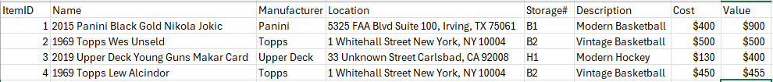

Normalized:
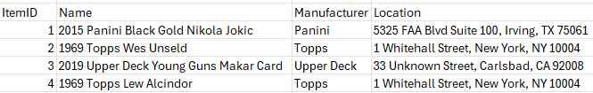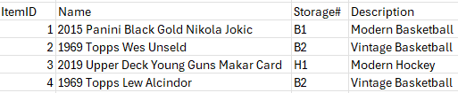
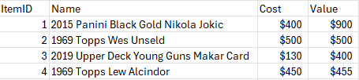
I chose to separate the manufacturer, storage box, and monetary cost/value in order to create a database in second normal form (2NF). The primary keys were the ID and the name, so I made sure that they were represented in each chart. I did it this way to make sure that they were normalized, and yet still easy to read.
- Turn the following table into a normalized relational database. Justify your design choices. Turn in a text document or word document of your normalized tables with a brief paragraph on your design choices.
This data model is for an inventory of home plants who have names.
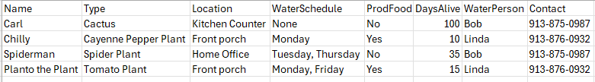

Normalized:
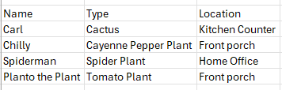
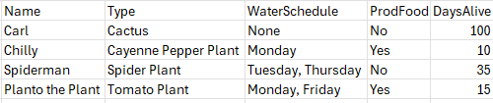
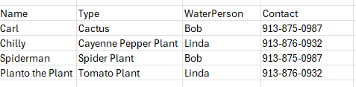
Much like the previous database, I normalized this in 2NF based on the primary keys. The primary keys, in this case, where the plant name and plant type. Of course, they are represented in the separate charts. Similarly, I did this so it could still be easily decipherable by a reader.

